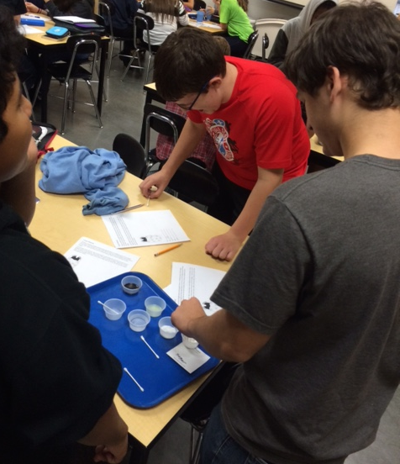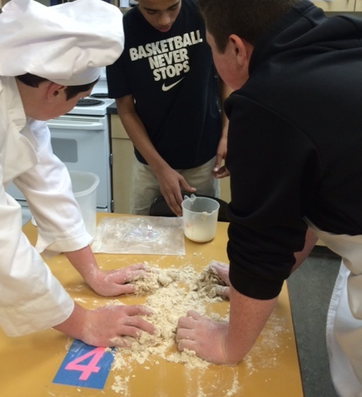

8:30am – 3:30pm

tswain@nsd.org

12101 NE 160th ST Bothell, WA 98011

Click here to

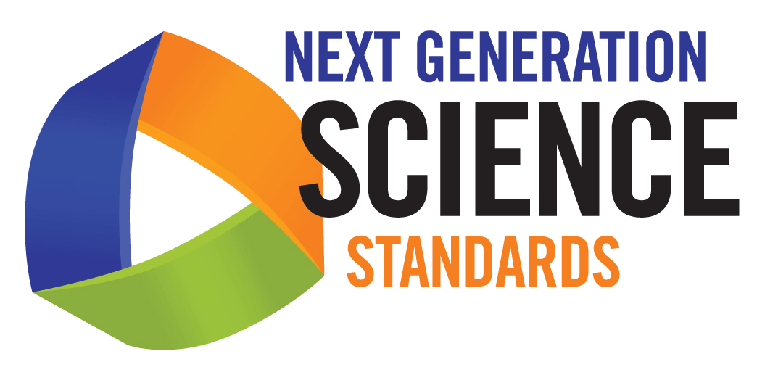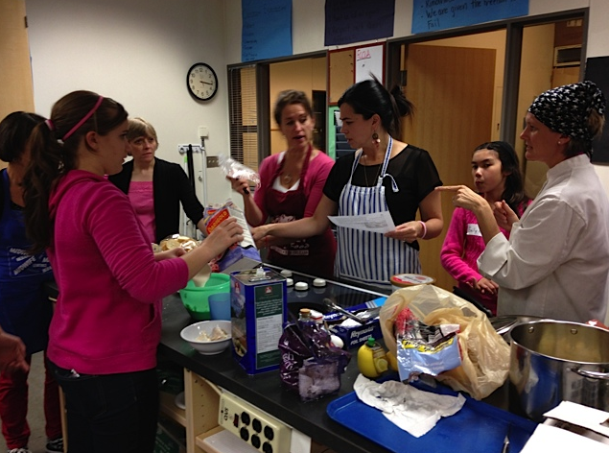[**Register**](https://drive.google.com/open?id=1JPuyK7gmt6Df9D2fNm3dnLBLcXJjGYCx3wqxIj83iPQ)

This Professional Development opportunity is offered to Family and Consumer Science teachers. Half of the training will be spent with a regional science coordinator taking a deeper dive into the 3-dimensional model of teaching the NGSS. The other half will be spent in the lab with a FACSE Food Science teacher practicing the implementation of the NGSS in two food science labs.

Transform your FACSE classroom by implementing the NGSS as a 3 dimensional teaching tool

**Tuesday May 10, 2016 Ft Vancouver High school or**

Lunch will be provided

Grants will be available for Travel, sub and supplies

Questions?

OSPI Program Specialist, Mary Nagel offers this training.

## **Monday, May 16, 2016 Northshore Junior High**

Food Science